SERVICENOW PROJECT

Automated Network Request Management
  - Functional Specification & Technical Handover

Document type | Functional specification document
Platform | ServiceNow Personal Developer Instance (PDI)
Instance reference | dev446474 (Australia release shown in instance)
Document date | 20 October 2026
Source templates | Final Report Template; FSD Documentation Format; UAT template
Project owner / identifiers | SkillWallet ID: SWUID2026232277. Project tester/demonstrator: PILLEM RAHUL. No additional team members were supplied.
Document status | Template-aligned ServiceNow technical handover. SkillWallet ID and GitHub repository are included. The narrated demo is recorded and included at Project Demonstration/Automated_Network_Request_Management_Demo_With_User_Voice.mp4; public GitHub video URL awaits upload. Open QA and data-integrity follow-ups are disclosed.
GitHub repository | https://github.com/rahulp06/Automated_Network_Request_Management_in_ServiceNow

Prepared from observed instance screens and tester-confirmed outcomes. Credentials and full test-mail address are intentionally omitted.

Adaptation note: the supplied FSD template contains MERN-stack placeholders. This implementation is ServiceNow-based; sections that referred to React, Node.js, Express, MongoDB, npm commands, or custom REST endpoints have been replaced with platform-appropriate documentation.

1. Introduction

1.1 Project title
Automated Network Request Management (ServiceNow catalog item: Network Request / Network Request Management).

1.2 Team and roles
Project tester/demonstrator: PILLEM RAHUL. SkillWallet ID: SWUID2026232277. Individual project submitter; no additional team members were supplied. The documented test operator used an administrative account in the Personal Developer Instance.

2. Project Overview

2.1 Purpose
Provide a structured Service Catalog intake for network-service requests, validate mandatory variables, create request records, route decisions through the configured approval workflow, and notify stakeholders about lifecycle events.

2.2 Key features
- Network Request catalog item accessible through Service Catalog > Top Requests.
- Mandatory variables observed: Requested For, Opened on behalf of, Mobile Number, and Type of Connection.
- Additional fields observed: Total Amount, Mode of Payment (UPI/CARD), Address, and derived requester information fields.
- ServiceNow creates a parent Request (REQ) and a related Requested Item (RITM).
- Existing approval and rejection workflow, request/item state tracking, and notification generation.
- Outbound email verification with global test-recipient routing and a custom SMTP sender.

3. Architecture

3.1 Platform components
Layer / component | Responsibility
User interface | Service Catalog item “Network Request / Network Request Management”.
Validation | Required catalog variables block an order when missing.
Request records | ServiceNow Request and Requested Item records; observed parent/child pair REQ0010004 / RITM0010005.
Workflow | Existing configured approval path supports approval and rejection; implementation internals were not independently inspected.
Notifications | Email notification records for submission, request creation, and approval messages.
Outbound delivery | Active custom SMTP account, smtp.gmail.com, port 587, STARTTLS; test routing through glide.email.test.user.
Inbound mail | Diagnostics showed receiving non-operational and no mail received; inbound processing is not required for verified outbound workflow.

3.2 Logical architecture
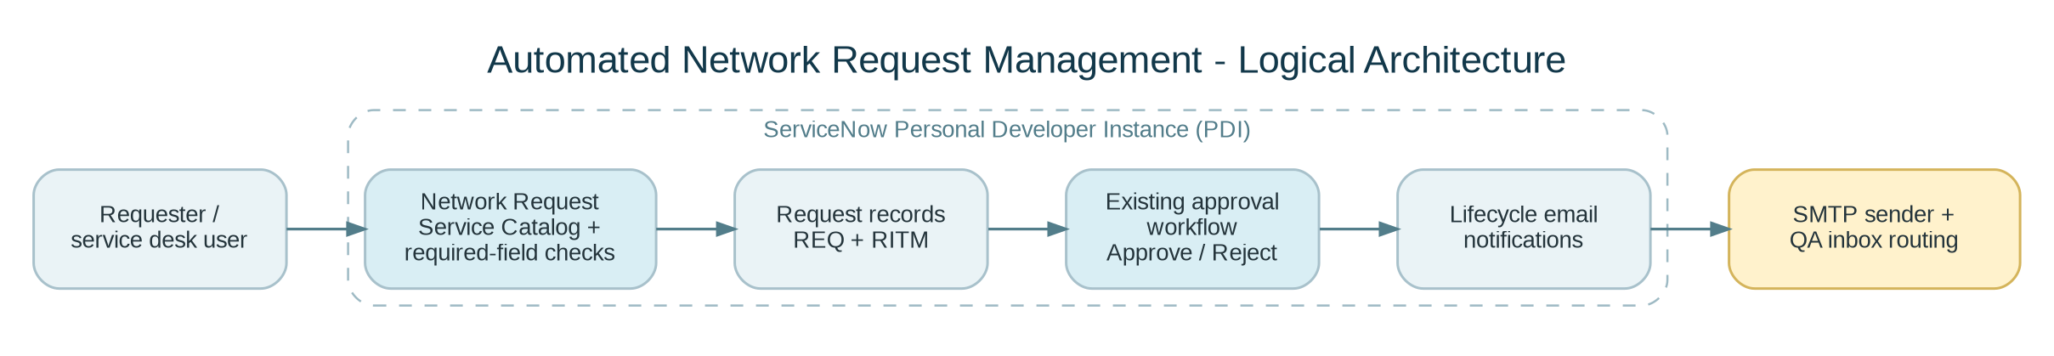
Figure 1. Logical component architecture based on observed behavior.

3.3 Data model and relationship
Observed relationship: parent Request REQ0010004 contains one Requested Item RITM0010005. The item’s Request reference points back to REQ0010004. Quantity is 1; item is Network Request; Stage is Request Approved; State is Open. Approval and Request state on the parent were both Approved.

4. Setup Instructions

4.1 Prerequisites
- Authorized access to the ServiceNow PDI and permissions to open the Service Catalog, Request records, email properties, and email account configuration.
- A test inbox for email QA and permission to configure the supported SMTP sender. Never place account passwords in this document or a source repository.

4.2 Open the application
1. Sign in to the authorized instance at https://dev446474.service-now.com.
2. Open Service Catalog > Top Requests > Network Request (shown as Network Request Management on the form).
3. Fill required variables and submit with Order Now. ServiceNow creates the REQ and RITM records.
4. Use the existing approval workflow to approve or reject; review the resulting request state and notification records.

4.3 Email QA configuration (sensitive settings omitted)
Setting | Documented QA configuration / guidance
PDI-level email control | Enabled during troubleshooting.
Instance outbound setting | Email sending enabled.
SMTP endpoint | smtp.gmail.com, port 587, STARTTLS.
Authentication | Google App Password entered directly in ServiceNow; secret deliberately omitted.
SMTP account | Network Request Test SMTP; activated after the connection test succeeded.
Test recipient route | glide.email.test.user points to a disposable QA inbox; full address omitted. Routing is global.
Email receiving | Diagnostics still reported non-operational; verify/disable if inbound email is not required.
Queue | Last observed count: 5 remaining after starting at 20. Inspect before clearing test routing.

5. Folder Structure / Configuration Inventory
No custom client/server code repository was supplied. The implementation documented here is principally a ServiceNow configuration:
Artifact | Purpose / location to inspect
Service Catalog item | Network Request / Network Request Management; catalog variables and required markers.
Request and Requested Item | Standard REQ / RITM records created by catalog ordering.
Approval process | Existing configured approval workflow/flow. Exact internal steps were not audited in this handover.
Notifications | Email notification definitions and generated email records.
Email Properties | Outbound setting and `glide.email.test.user` test-routing property.
Email Accounts | Network Request Test SMTP; credentials are not included.
Email Diagnostics | Sender state, queue count, last-sent timestamp, inbound diagnostics.

6. Running the Application

6.1 Normal request path
1. Open the Network Request catalog item.
2. Fill Requested For, Opened on behalf of, Mobile Number, and Type of Connection; supply any other appropriate variables.
3. Choose Order Now. Verify successful order creation and note the REQ/RITM numbers.
4. Wait for the existing approval path, then verify the decision and notifications.
5. For QA, keep test recipient routing active until queued messages are understood; it redirects all outbound platform email, not just this item.

7. API Documentation
No custom API endpoints or API contract were supplied or demonstrated. This project was exercised through the ServiceNow UI and built-in catalog, request, approval, notification, and mail capabilities. Any custom Flow actions, scripted REST APIs, or integration endpoints must be added here only after inspecting the instance and collecting their exact definitions.

8. Authentication and Authorization
Access is provided by the ServiceNow instance login and platform roles/ACLs. Administrative access was used during the observed testing. The precise ACL and role configuration was not independently audited, and this document does not claim a security review. Do not include instance passwords, Google App Passwords, or other secrets in the project submission.

9. User Interface
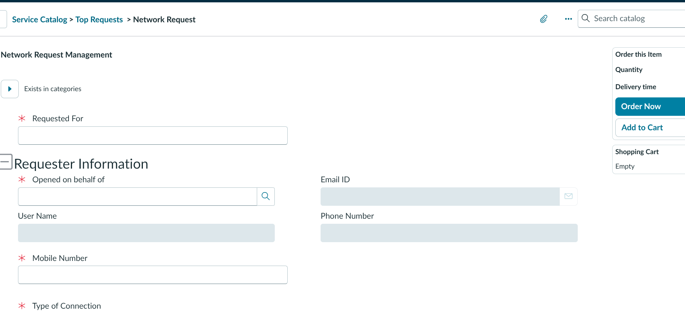
Figure 2. Network Request catalog form with required-variable indicators.
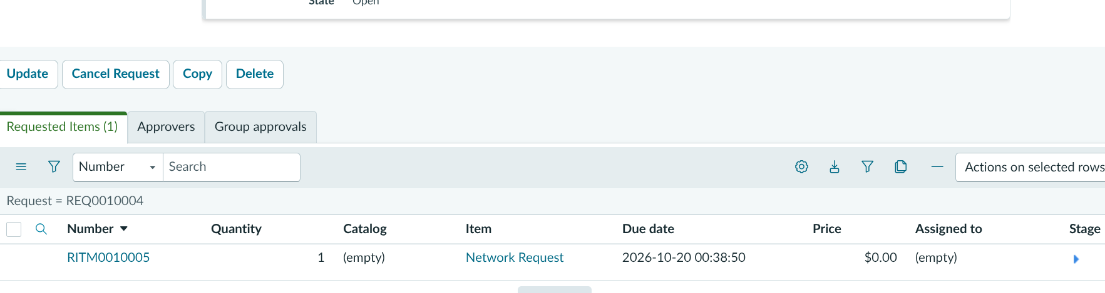
Figure 3. Parent Request and linked Requested Item related list.

10. Testing
Test | Result | Notes
Required-variable validation | PASS | Order Now was blocked when required values were left blank.
Request / item linkage | PASS | REQ0010004 linked to RITM0010005.
Approval / rejection | PASS - tester confirmed | Exact rejection test record ID was not captured.
SMTP connection | PASS | Succeeded after App Password was re-entered without spaces.
Outbound delivery | PASS | Test inbox showed Network Request notifications.
Full queue drained | FOLLOW-UP | 5 messages remained; individual records not yet inspected.
Formal performance/load test | NOT TESTED | No load or concurrent-user test was performed.
Inbound email | OUT OF SCOPE / REVIEW | Diagnostics showed non-operational receiving.

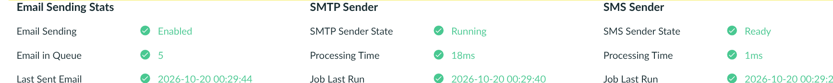
Figure 4. Email diagnostics after SMTP activation. Temporary test address is omitted from the evidence image.

11. Screenshots / Demo
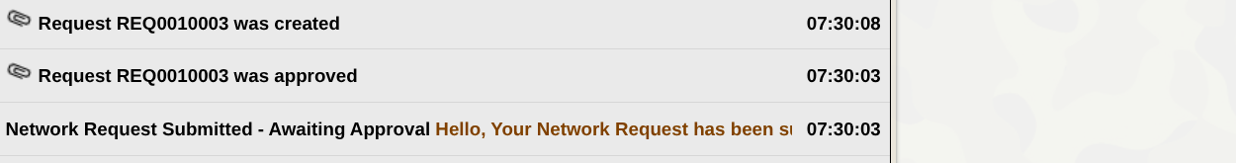
Figure 5. Cropped inbox evidence of received Network Request notification subjects; address columns omitted.
GitHub repository URL: https://github.com/rahulp06/Automated_Network_Request_Management_in_ServiceNow. Demo video included in package: Project Demonstration/Automated_Network_Request_Management_Demo_With_User_Voice.mp4 (~98 seconds). Public GitHub video URL: pending repository upload. Do not include instance credentials, SMTP credentials, App Passwords, or the full disposable test-mail address.

12. Known Issues and Follow-ups
- Five outbound email messages remained queued at the last observed diagnostic refresh. Inspect their state and purpose before changing routing or deleting any message.
- Email receiving was reported non-operational and no inbound email was recorded. Inbound mail is not required for the tested outbound workflow, but the saved receiving setting should be reviewed.
- Approvers and Group approvals related lists on one parent Request appeared empty even though its Request state and Approval were Approved. Trace the actual approval record if formal audit evidence is needed.
- TASK0020173 was created on the generic task form during navigation/testing; Short description was blank and the record was left unchanged. Review under project cleanup policy.
- Performance/load testing, precise ACL review, and production mail configuration review remain unperformed.

13. Future Enhancements
- Capture approval record identifiers and rejection evidence in the test log.
- Add regression checks for all mandatory catalog variables and the approve/reject lifecycle.
- Use approved organizational email delivery and secret management for production; remove test routing only after queue review.
- Define a fulfillment completion path from Request Approved / item Open to the final fulfilled/closed state, if not already configured elsewhere.
- Run performance and security tests; document an explicit production readiness checklist.

